|  |  |  |  |  |
| --- | --- | --- | --- | --- |
| **National University of Computer and Emerging Sciences, Lahore Campus** | | | | |
|  | **Course Name:** | **Programming Fundamentals** | **Submission date** | **13th November 2021** |
| **Assignment** | **1** | **Total Marks** | **80** |
| **Section** | **BDS-1B & BDS-1D** | **Weight** | **5** |

**Question 1 [marks = 4 + 5 = 9]**

**a)**

Write a c++ program that can calculate the value of ***pi*** up to a certain accuracy using the Leibniz formula for pi.

The accuracy i.e. the number of terms to calculate (n) is taken as input from user.

Sample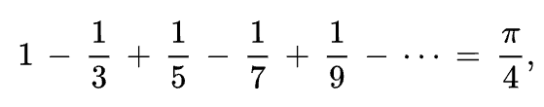:



**b)**

Write a c++ program to calculate the value of ***ex*** up to a certain accuracy using the series expansion given below.

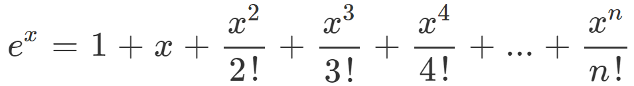The program must take two inputs from user. The value of *x* to evaluate, and the value of n i.e. the number of terms to compute.

Sample:



**Question 2 [marks = 6 + 6 = 12]**

**a)**

Write a c++ program that takes as input a denary number then calculates and displays the binary equivalent. You may use the ***unsigned long long int*** data-type to store the binary number in case of large denary value.

Sample:



**b)**

Write a c++ program that performs the opposite operation i.e. takes a binary number then calculates and displays the denary equivalent.

Sample:



**Question 3 [Marks = 6 + 2 = 8]**

**a)**

Write a c++ program that takes a number N then calculates and displays its reverse. For example, for input 12345, the expected output is 54321. You may assume that the input numbers do not end in a zero.

Sample:



**b)**

Using the logic developed in part (a), create a program that checks whether a number is a palindrome or not. A palindrome number is a number that is the same when read from left to right, or right to left. For example, 12021 is a palindrome number. 123 is not a palindrome number.

Sample:



**Question 4 [Marks = 8]**

Write a c++ program that will indefinitely take a binary input of 0 or 1. However, upon receiving a special code pattern of 10101, the program will stop the input, output “Input Terminated”, and then the program will terminate.

Sample:

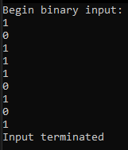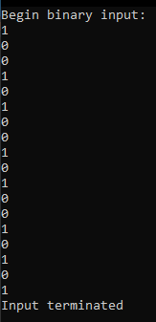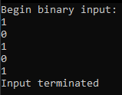

**Question 5 [Marks = 8]**

Write a c++ program that displays all the prime factors for a number n, where n is taken as input from the user. If the entered number is prime and has no other factors, output “Number is prime”, otherwise output the factors.

Sample:



**Question 6 [Marks = 3 + 3 + 4 = 10]**

**a)**

Write a c++ program that takes an input n corresponding to the height of a pyramid. The program then constructs a pyramid using ‘*’. The pyramid must always have an odd number of * at its base.

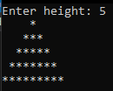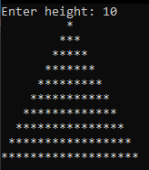

**b)**

Write a c++ program that prints the diamond pattern shown below. Take an input n corresponding to the height of the upright pyramid portion of the diamond.

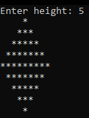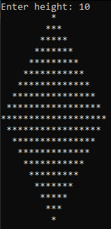

**c)**

Write a c++ program that prints a hollow pyramid using *. Take an input n corresponding to height of the pyramid.

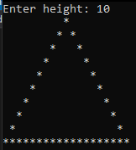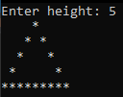

**Question 7 [Marks = 15]**

A student wants to know the general shape of a linear equation when plotted graphically. Write a c++ code that takes as input two coordinates (x,y). The program then calculates an approximate linear equation (gradient and intercept are integers) and plots it onto the console. If the line interacts with x or y axis, make sure that axis is visible. Assume that the line cannot be vertical.

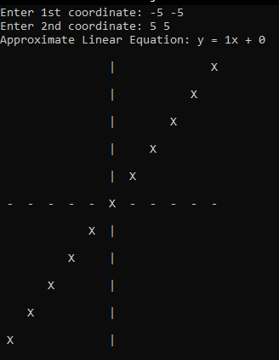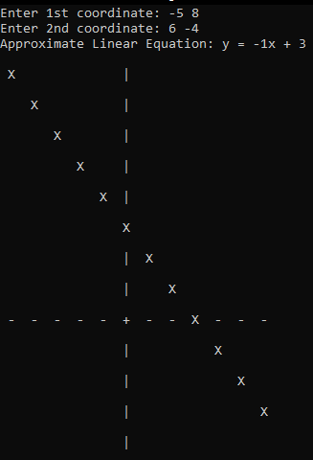

**Question 8 [Marks =10]**

A mathematician is interested in finding numbers with special properties. The numbers he is looking for are numbers that equal the sum of their digits raised to the power of the number of digits. For example:

153 is a special number since:

Number of digits = 3

13 + 53 + 33 = 153

8208 is a special number since:

Number of digits = 4

84 + 24 + 04 + 84 = 8208

99 is not a special number since:

Number of digits = 2

92 + 92 = 162 != 99

Your task is to write a c++ program that can find all such special numbers from 0 to n. Take n as input from the user.